You do not need to evaluate any condition or event in the parallel gateway. Instead, a parallel gateway is used to represent two concurrent tasks in a workflow. for example: The company takes the cake and eats it.

An exclusive gateway evaluates the state of the business process and, depending on the situation, breaks the flow into one of the mutually separated ways.

An inclusive gateway breaks the process flow into one or more flows.

Camunda is open source platform for Business Process Management. Camunda BPM is a Java-based framework. The main components are written in Java. Camunda BPM also provides a REST API which allows you to build applications connecting to a remote process engine.
The Camunda Modeler is an easy-to-use app for editing BPMN process diagrams. You can deploy the created files to the Camunda Engines in order to execute them.
With Camunda Cockpit you can monitor workflows and decisions in production to discover, analyze and solve technical problems. Cockpit is the perfect tool for technical process operations.

Workflow net is a special type of a petri net that is suitable for expressing workflows

In a workflow net:
- there's a clear start:
  - the unique dedicated input place i s.t.
  - ∙I=∅
  - i.e. no transition can put a token to “I”
- there's a clear end:
  - the unique dedicated output place “O” s.t.
  - O∙=∅
  - i.e. no transitions should consume tokens from O
- every other transition and place are on the path from I to O

Soundness is a concept of the correctness of workflow nets.
There are situations that we want to avoid:
- unboundedness
- cycles and deadlocks
- dead transitions
For that we define the following properties
- Option To Complete
- Proper Termination(Ending)
- No Dead Transitions

Unboundness means:
- there is no bound on the number of tokens that a place can hold
- this always means a problem

Both livelock and deadlock mean that there's a situation when you cannot reach the end.
In Deadlock, for ex you create xor split, and join. There is not token in output place, so that we don’t have matching join and it can not reach to the end.
In Livelock, there is a cycle, some nodes can fire forever, they are always enabled, so that you can not reach to the end.
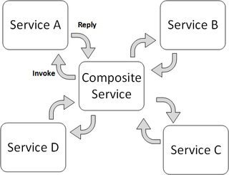
Service orchestration represents a single centralized executable business process (the orchestrator) that coordinates the interaction among different services. The orchestrator is responsible for invoking and combining the services. The orchestration includes the management of transactions between individual services. Orchestration use a centralized method for service composition

Service choreography is a global description of the participating services, which is defined by exchange of messages, rules of interaction and agreements between two or more endpoints. Choreography employs a decentralized approach for service composition. Choreography differs from an orchestration with respect to where the logic that controls the interactions between the services involved should reside.
